Log
Date | Comment
2023.4.27 | Today I took part in a lecture about the ipq program in our school, which provided an overview of this project. The lecturers introduced the outline of the program and mentioned two ways to conduct scientific research, which are a literature review and a research paper. Teachers asked us to make a choice and collect thoughts in our daily lives to select a proper direction for the research.
2023.5.6 | I read an article from the Institute of Physics, Chinese Academy of Sciences, about making a pendulum-type toy with rulers and pens. It inspired my interest in this mechanic. I learned about the concept called a compound pendulum, then I combined it with the simple pendulum taught in school recently. I can do further research on this aspect.
2023.5.11 | School organizes the second lecture on writing essays, so I immediately go through it. The teachers shared various methods to specify topics and find relevant essays, which include GOOGLE SCHOLAR and some websites. They are really useful and can sometimes help me to build up a foundation before I choose a certain topic.
2023.5.13 | Today I read some physical articles about pendulums. I enriched my knowledge of the use of oscillation and the mathematical form of mechanics, which can help me to work out accurate forms of a period when calculating that of a simple pendulum. But I still have some confusion about the compound pendulum: What are the differences between it and the simple one? How can I get a compound pendulum?
2023.5.14 | Some further introductions about the compound pendulum are read these days, and as a result, I get a much clearer view. To simplify it I conclude my understanding, that a compound pendulum is one with continuous mass distributed in space of an object and rotates about a certain axis, but the simple pendulum is that no extra massive support is considered when oscillating and can be considered as a massive dot. As to this, I think further investigations will be able to proceed since I can understand the academic forms of physical pendulums.
2023.5.17 | The coursebooks in A Level and others like University Physics I found yesterday only tell me how to get the period and movement equations in non-friction conditions, which is ideal and cannot be realized in reality. After chatting with my physics teacher, he told me I could delve into a deeper level, e.g., involving friction in the calculation.
2023.5.19 | Today I hand out the topic of my ipq program. Before certain the topic, I confirm to make research on the calculation of the period of compound pendulum in frictional conditions. So, my topic is 'The Effects on the Period of Compound Pendulum due to Damping'. Classically, this theoretical research can be divided into two parts, theory derive, and experiment approve. So, I planned my research into several stages:  [Calculation]: Formula derivation, to calculate the pendulum period.  [Material production]: Design and modeling of experiment materials.  [Experiment]: A system consists of A 3D printed plastic compound pendulum, Several steel/aluminum/iron compound pendulums with the same size and volume, stopwatch for time measurement.
2023.5.25 | I am pleased to hear the news that I have my tutor Mr. Henry to guide me when I am doing the research and facing any trouble during this process.
2023.5.31 | Today is the formal start of the program. I have the first communication with my tutor about the detailed plan and topic. He advised me to do further readings in the field of damping, especially to make a clear view of the type of friction, and most importantly the way of calculation.
2023.6.2 | I searched on GOOGLE SCHOLAR and did some literature reviews about it. Unfortunately, no useful information was found even if I looked up more than twenty of them. However, several damping is researched by public scientists and academies, such as atmospheric and electromagnetic, and random ones aimed at chaos systems.
2023.6.10 | After downloading three essays, 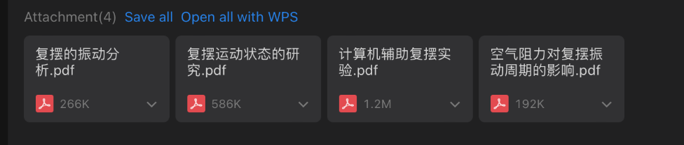  three choices are provided for me after considering factors including the complexity and time needed for experiments, measuring, and calculation. They are air damping, liquid damping, and electromagnetic damping which involves eddy current to create the damping force.
2023.6.19 | The summer holiday begins, so I contact my tutor through email. I sent him the choices and let him assess which one suits me the best. To my surprise, he answered me almost immediately, suggesting that less repetitive work should be done in academic aspects.
2023.6.25 | After careful judgment, I decided to choose liquid damping, mainly because it is easy enough for me to complete both the experiments and formulae deriving. According to the essay,  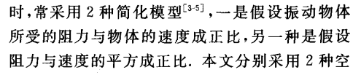  the fluid friction force can be simplified into two models: the proportional model and the square model. I can calculate and discuss the advantages and differences between both methods, which is an excellent topic, and I can get the result just after making some efforts. The next stage is collecting ways to get the correct formula and theories and delving into specific readings of essays in this field.
2023.7.10 | I finished the collection of papers in the compound pendulum field, while some have intended my hospitality and curiosity. Several of them are in the field of air and ideal conditions, but only a small proportion of them are mentioned in the field of liquid, which I maintained my desire to research in this direction.
2023.7.28 | For the past two weeks, I spent my spare time skimming most of the essays I downloaded and carefully read some of them in detail. Some provide a clear view of the process, but others jump rapidly from one conclusion to another. Today I also contacted my tutor through email and exchanged information about the selection of the type of damping, and he agreed with the choice of liquid, referring to some additional materials.
2023.8.5 | I contributed my primary understanding of the mathematical forms of getting involved with the use of differential equations and small angle approximation. At the same time, our ipq leader asked me to hand out the project proposal form by the end of this month, so I started working with PPF today.
2023.8.8 | Alerts were given out that we would experience the opening presentation after we returned to school. I started to make the PowerPoint and prepare for it.  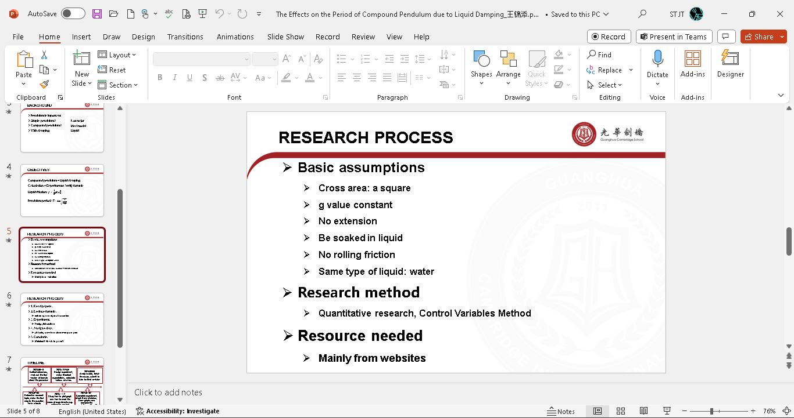
2023.8.13 | I completed the PowerPoint today and sent it to the tutor for checking. My presentation is divided into various parts. I began with the objectives and aims, listing the basic assumptions, the method of research, the resources needed, with a prediction of the project, and ended up with a timeline. The presentation will be 10 mins, so I think it would rather be a problem when speaking in front of teachers and students.
2023.8.20 | The tutor and I have achieved an agreement with the forms of presenting publicly, so I made some adjustments to the PowerPoint and switched some of the language in it. Then I hand it to the system.
2023.8.31 | Today is the opening presentation! I was the second one who did the presentation, with another three followed behind. Several teachers in the physics group asked me detailed questions, one even listed more than ten. I tried my best to answer them, as in the range of what I have learned. Problems focused on the experiment part, where a great amount of them were extremely interested in this, but I did not plan it very well at the present stage. Also, some suggested that it would be hard to obtain the experiment by myself, as it might be difficult to ensure the waterproof materials and the expected results.
2023.9.1 | I produced the idea that I may use 3D printing techniques to get the freedom for a suitable apparatus when proceeding with the experiment. I should ask some engineering classmates for external assistance.
2023.9.2 | I communicated with my tutor, and he supported me with the idea of 3D printing. He also recommended Python when analyzing the metadata and when needing to draw particular graphs. From the video websites, I studied the basic knowledge of both applications, and I will use it in the later stage. Also, some teachers advised me to make small fixes on the topic, as I am going to work on two certain approaches towards the period. Now my topic got its new form: Two Approximation Methods on the Period of Compound Pendulum with Liquid Damping. This seems more accurate than that before and lets readers know what I am going to do through the passage from the title.
2023.9.6 | The school organized another lecture on how to improve the accuracy of passages and beauty in language when drafting a report or an essay. The materials were extremely useful, so I saved them on my computer for reading.
2023.9.16 | I got the equation of analog Newton's second law in rotation. By substituting each term into the exact form for each variable, I can easily obtain the motion equation. However, the multiple forces acting on the pendulum’s surface, then use integration to add up and get the accurate value.
2023.9.20 | Suddenly I produced the idea that I just needed to assume a value at first, and not worry about its value, then by experiments to measure that value out and lead into calculations. The tutor agreed with my ideas and gave out detailed math forms for convenient use of the constant I assumed.
2023.9.25 | Massive amounts of articles had given out the small angle approximation for sine theta equal to theta, but I was confused about this fact. I know that small angles must be able to happen under no friction and low friction situations such as air, but is that so in water? I was really worried about this, but I do not know how to prove it, or I must consider big angles for the observable and recordable results, but that involves ellipse integration, and I can hardly manage to overcome this.
2023.10.4 | As it is a national holiday, I contacted my tutor through WeChat. He suggested I do a rough experiment to verify the availability of the small angles and do some elementary calculations such as friction constant and the over-damping value to refer to the exact data and conclude certain results. Now I start to consider what material I should choose to finish the rough experiment.
2023.10.18 | After solving several quantitative mistakes, the first formula of the compound pendulum in the direct proportional model was worked out and successfully passed the examination of boundaries and extreme tests! I almost spent an entire week on this and wrote it into a Word document. With the aid of tools like Mathematica and Wolfram Alpha, the homogenous first-order linear differential equation can be solved nicely and well, although its complexity was always suspected to me. It turned out that I made mistakes more than the machine, but I will recheck when I move on to the next model.
2023.11.10 | The second model was not as easy as the first one, and I can hardly find related resources about this type of equation and also its solution. Some high-level students can give me a favor when solving the problem as it touches second-order non-linear ordinary differential equations.
2023.11.15 | In recent days, I imaged using a long screw to function as the pendulum and dig a hole through it to go through the axis. I have several such objects at home but no holes through them, as drilling tools failed to make one.
2023.11.19 | I found a shop selling iron and metals that can achieve the want of digging. A copper wire is going to be used to perform the rotation axis, and a glass water tank will be used to contain water and ensure photographing. I worked up till evening, so I prefer to experiment tomorrow.
2023.11.20 | Today I did my rough experiments.  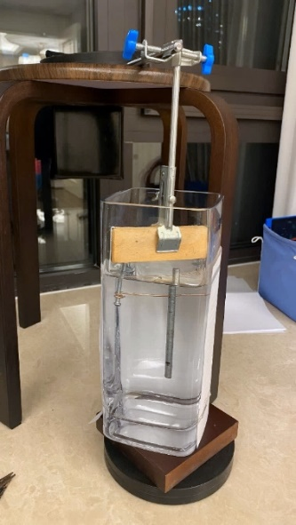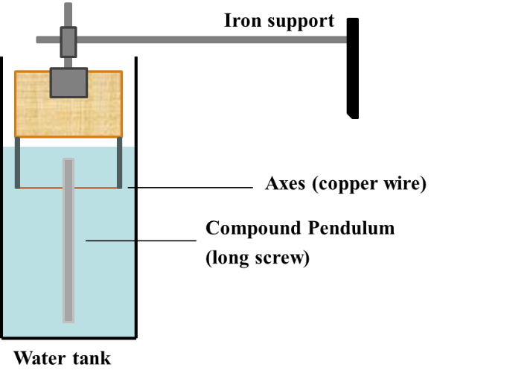  The result was expected that small angles were available under water-damping conditions, and the experiment proved this hypothesis. It is glad to see this conclusion, which means I do not need to focus on ellipse integration and release the press during mathematics. The data was collected in Excel, but I am currently not prepared to analyze it quantitatively. It will be done in December.
2023.11.22 | These days I concentrated on the mid-term presentation, which can be a big case at this moment, so I have to prepare carefully. Some models are used to categorize my PowerPoint styles, and references are found to support some of my opinions such as why I should use two approaches but not only one, and the heat discussion in the academic field.
2023.11.25 | Today I finished the first edition of the PowerPoint and handed it to my tutor for further assistance. Also, an outline is going to be written these days to plan in detail and list the basic structure of the essay. This can be important and reduce the time wasted when I am writing the passage.
2023.11.26 | My tutor met with me today and gave small suggestions for the research: I did not clearly state the title which can easily cause misunderstanding by the audience, and some formulas in the PowerPoint have style errors. I made small corrections to it, and I will prepare for the presentation in the following days.
2023.11.28 | Today is the mid-term presentation! Seven teachers listened to my presentation and five of them raised their specific questions. A major part of the speech, however, was not aimed at confusion, where concentrated on the ways to realize formal experiments. Some argued about the availability of 3D printers when experimenting, and some questioned the process of my project. I denied the uncertainty of plastic models gave particular examples and asked about the availability of the 3D printer in our school. The mentor agreed with that idea and gave me the contact card of the teacher who was responsible for it. To my surprise, most of the audience gave me high support and expectations, which I wondered whether I could meet their demand.
2023.11.30 | Today I contacted my school 3D printer teacher, and she agreed to the free use of the printer. I was extremely excited and decided to begin the study of modeling immediately.
2023.12.3 | I found a lot of resources on bilibili.com about the modeling application blender. This is the most popular use of modeling in both professional and academic aspects, which also has a high social state combined with a large community. This can be a viable choice for me.
2023.12.5 | I worked out the first model of the container I am going to use.  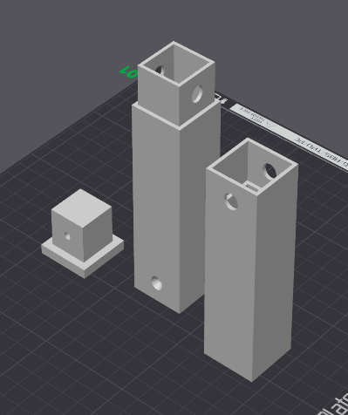  The experiment, according to my expectations, will be selecting the mass center as the variable, and detecting the period of oscillation by video cameras. The data will be recorded and analyzed. I do not have a large water tank, so the length of the container will be 20cm and 3cm wide. The inner is space and can put different masses into it.
2023.12.10 | According to the size of the inner side, I bought the masses. They all have similar shapes but differ in mass. They are now transferred to my home today through the road, and the next stage will be the study of Python. Also, I spent the time majorly in writing the formula into the Word document. This process was boring, but no tools aided me.
2023.12.12 | After communicating with an engineering classmate, he pointed out a big problem in my model, that no ensure of waterproofing protection between the splits and mass center can change during the experiment. He helped me fix my model and told the method to produce it correctly in the printer. Cautions were listed and tips were useful. I then handed the model to the printer and wished to get a chance for printing but failed. I will do this later.
2023.12.20 | These days I read the documents and manuals about Python and installed it on my computer. It is a very contributive tool and has a sea of libraries written by all kinds of researchers to assist scientific calculation and graphics. I did study Python before in school, but this can be new learning for specific aspects of this program tool, particularly numpy lib.  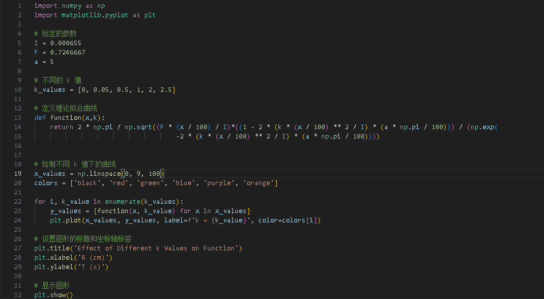
2023.12.28 | I used Python to calculate the constant in the rough experiment, and it gave out the result in less than a second. Surprisingly, computers can run so fast nowadays and also plot graphs the same as I imagined.  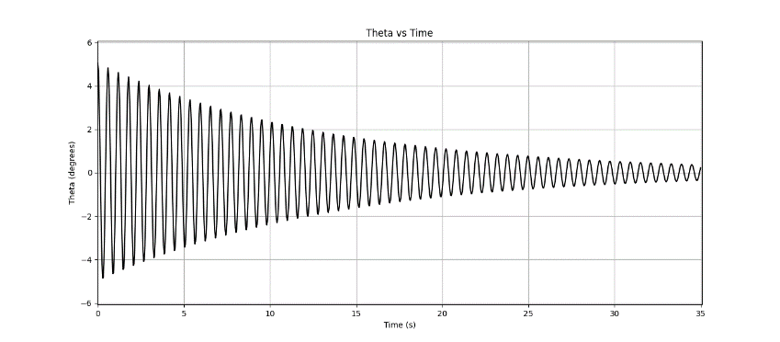
2023.1.2 | Today I managed to print out my model. I tried three times in total, where the first one stopped in the middle, the second broke down before starting, and the third one was the final product. I deal with all kinds of errors alarmed by the machine and reset the original data repeatedly. This was really a troublesome process. I will try to communicate with a factory to help me print out the model next time. However, some apparatuses are still on the road, and I cannot start the experiment immediately.
2024.1.9 | Today I tried to interact with ChatGPT 3.5 to assist me with programming. He answered in a very polite and clear manner. I think he can improve the efficiency when it comes to programming in daily life or dealing with the data and putting them into a table. He can reduce the frequency of repetitive work.  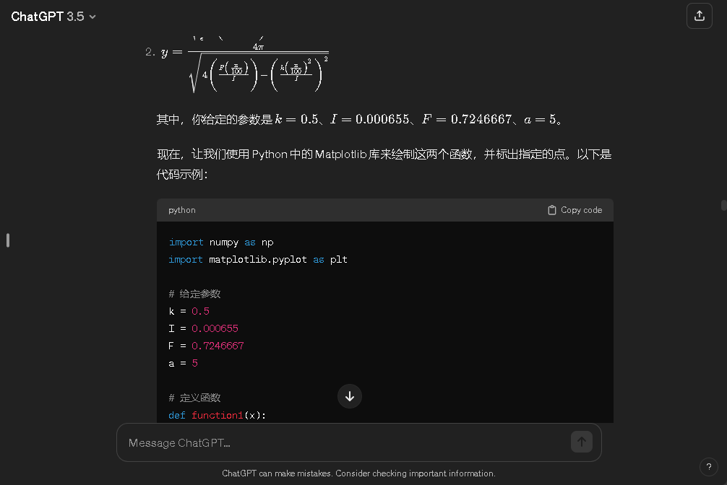
2024.1.15 | The mass blocks arrived, and I can design the experiment. It is necessary to determine their masses accurately so I can obtain a better result. Waterproof was so important that it needed to become an individual discipline, and also to ensure the same total weight, as it is not considered as a variable. Supports are needed and have to be light and hard to build up the inner structure. And I may go to the school to do the experiment as there was no suitable bucket.
2024.1.18 | Today I prepared for the formal experiment. I combined the entire container together and evaluated its stability. The size just fit my request, so it is glad to process the experiment tomorrow.  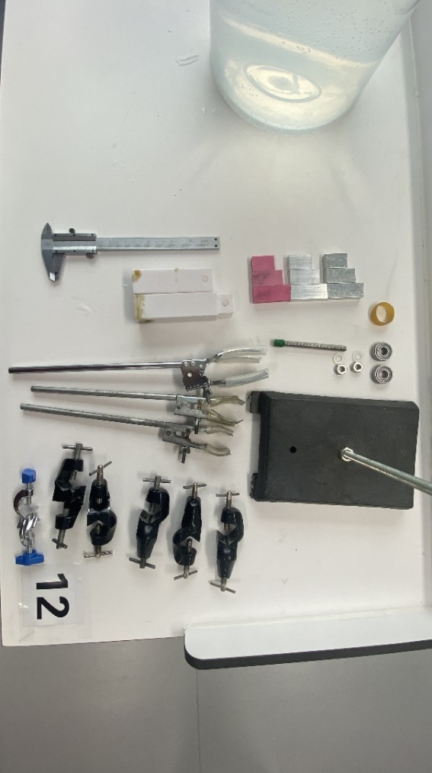
2024.1.19 | Today I did the formal experiment individually at the school’s laboratory. I took ten sets of data but two of them may become useless because of the lack of carefulness. The camera went wrong midway, but I still succeeded in taking all the slow-motion videos and recording them into the editor. At the end of the experiment, the data were troubled which did not appear to be the right one, but I will analyze them later.  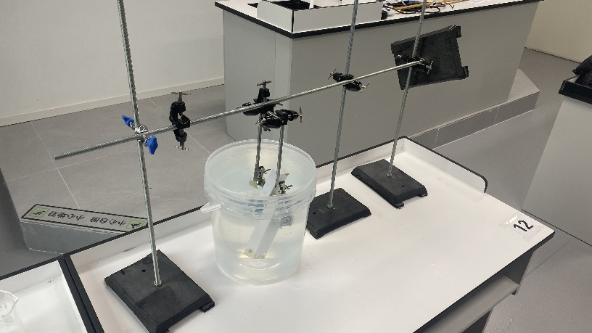  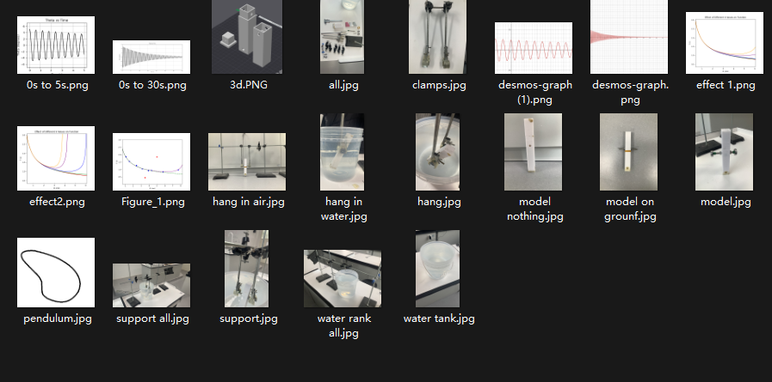
2024.1.25 | In recent days I have used demos to adjust and find the suitable value of the constant in the experiment. I entered the data into Excel and I neat them. Python was also used to build up that value but has small effects. In my spare time, I also finished the experiment part, and I am going to begin with the analysis.
2024.1.26 | Today I calculated all the figures I needed and ensured they were in a polite manner. I was so excited to see how fit the data was with the theoretical line! This means I did a very wonderful job in both aspects. I also read some articles about overdamping conditions for a pendulum, and I am thinking about putting them into the essay to make further quantitative research into the rough experiment.
2024.1.31 | I used ChatGPT to help me plot all the data graphs in a clear and obvious way. He also pointed out the suggestions for analyzing the data about the clear statement for each table and diagram, and if necessary, should draw illustrations. Though he is a machine, I feel like he can become my teacher.  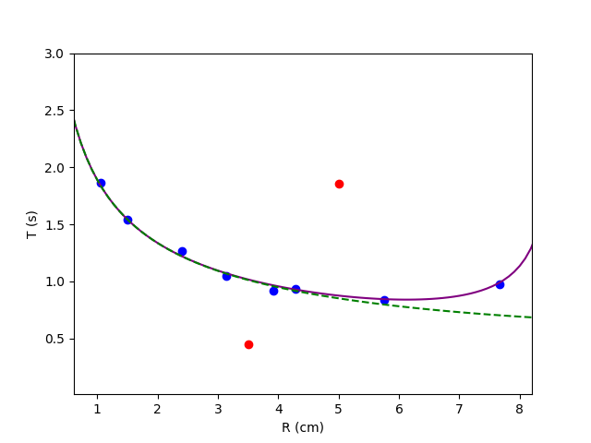
2024.2.5 | Today I finished the analysis of the formal experiment. This part occupied the biggest number of words and needed to pay more attention. However, I need to reflect on myself as a lot of problems appeared during the research project, so the last section will be reflecting and concluding.  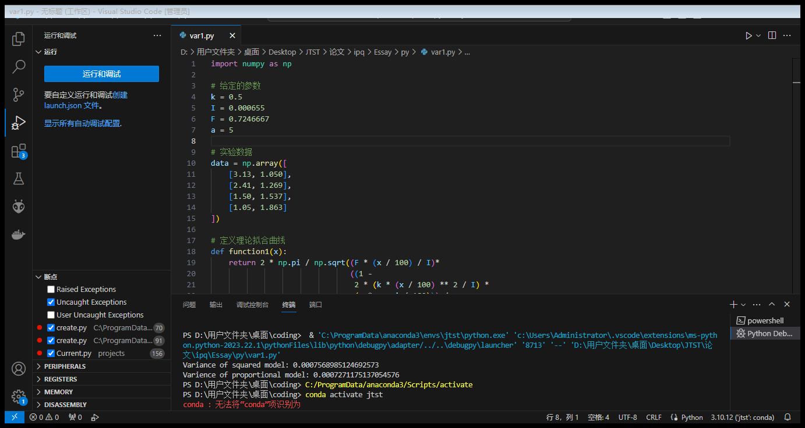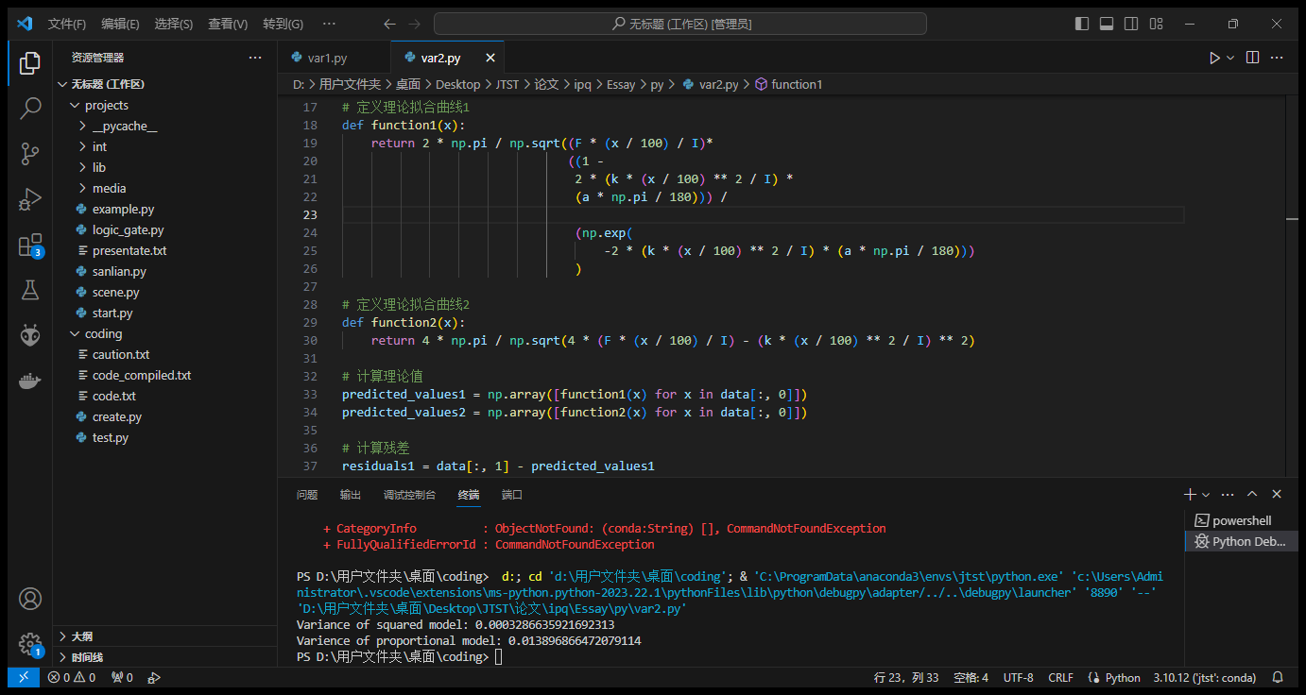
2024.2.10 | Today I finished the first draft and restored all the references into the essay. Styles will be adjusted later, and I handed over to my tutor for suggestions. The process ends!  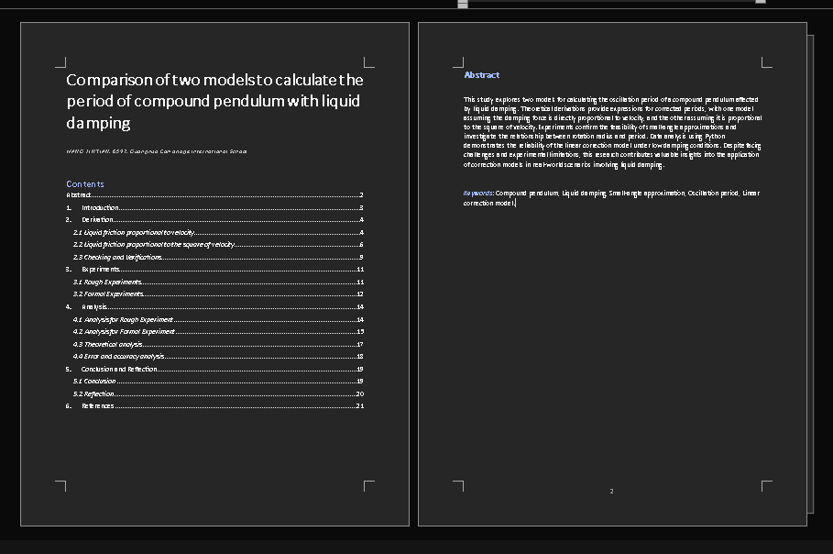
2024.2.21 | After the winter holiday, I contacted my tutor and diminished his confusion in my first edition. He said I needed to examine another data at the ledge radii condition because it causes argument but only one set of data to support it. I recorded the suggestions onto the computer and prepared for another small redo of the experiment next week.
2024.2.26 | Today the mentor held the second group meeting. He announced the deadline for the ipq project and the time to going the final presentation. I will prepare for them from now.
2024.2.28 | I redo the experiment today and added it to the table. Some graphs were redrawn, and I also did small fixes to the essay. Then I create the folder of the final presentation.
2024.3.2 | Today I finished doing the PowerPoint of the final presentation. It will take about 15-20mins the week after next. I will be preparing for the presentation in recent days.  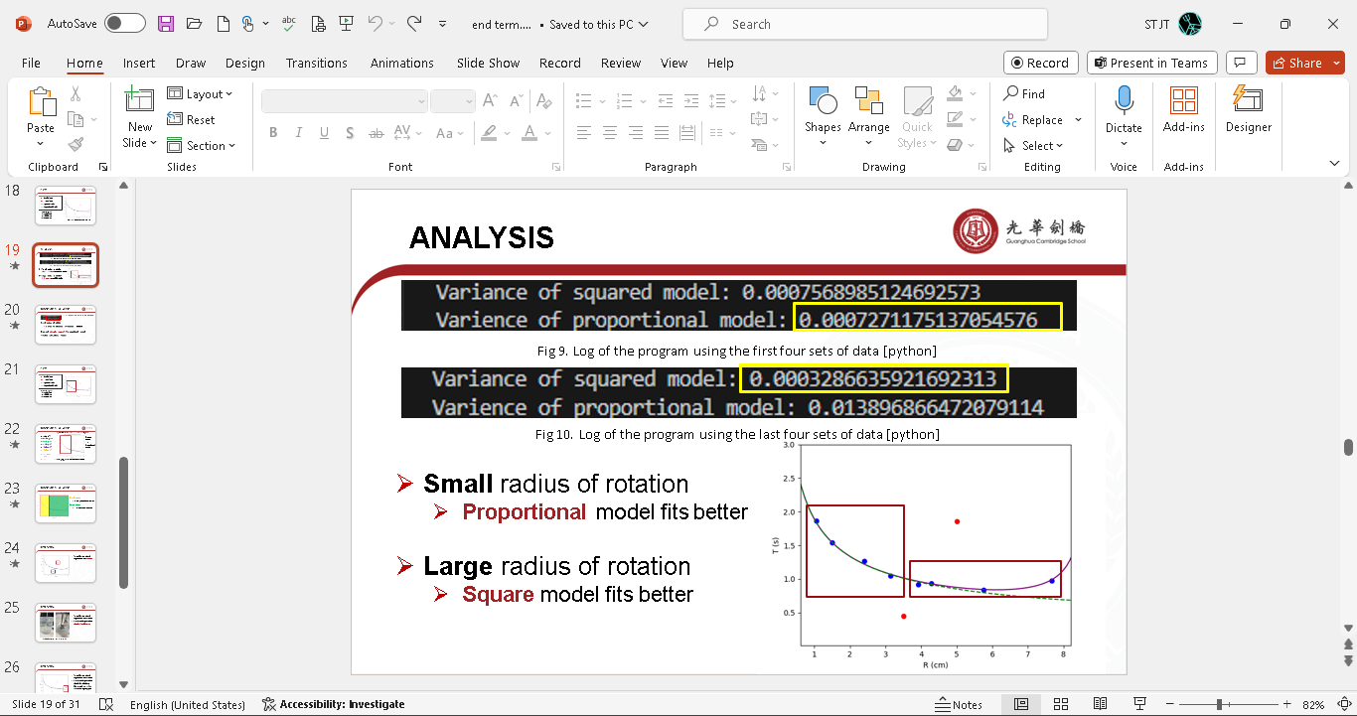
2024.3.5 | Today I met with my tutor again to check the PowerPoint and the materials I would talk about during the final presentation. He agreed with the length of it but confused about whether I will be able to finish, as the time was shortened into 10 minutes. I decided to delete some parts in the PowerPoint in order to make it fits the time.
2024.3.7 | I started to focus on the language accuracy and grammar errors in the essay, since I realized that this can greatly affect the passage. I also sent my PowerPoint to the mentor today. Formula styles were disgusting as they need to be redone by hands.
2024.3.10 | These days I used Grammarly to check the spelling and the grammar mistakes. More than 10 were found out so I was pretty worrying about its clarity and correctness. My final edition will be produced on Mar. 31st.
2024.3.12 | Today I took part in the final presentation and made the last representation of my ipq project. The process lasts about 8 minutes and one of the teachers asked me a question of the detail of the experiment. I explained briefly because the time is limiting. My tutor talked to me later about the problems on the manner and politeness when doing the presentation and congratulated me with the finish.  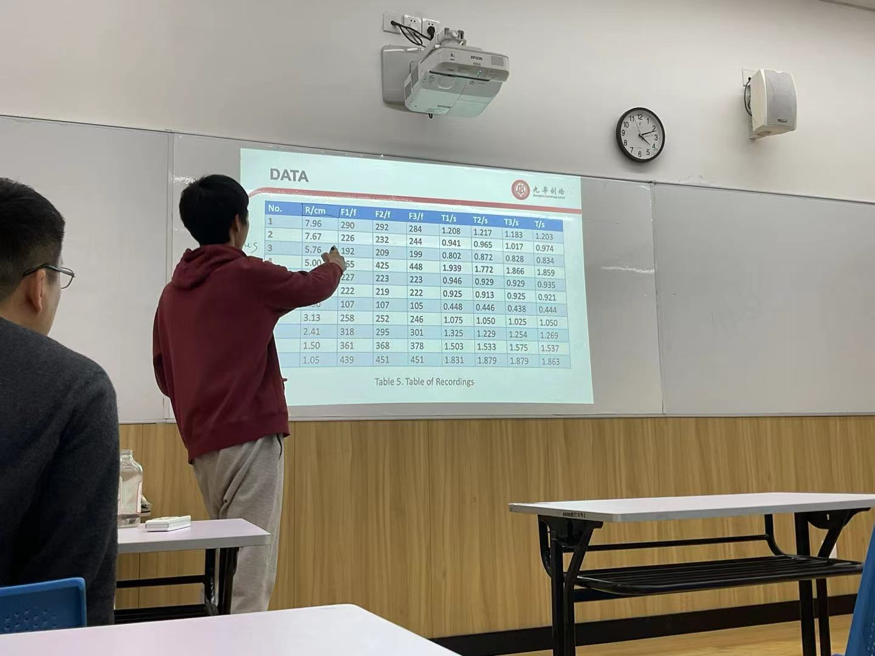
2024.03.15 | Today the mentor collected my essay which was in second edition to show it in the teachers’ meetings, while he also pointed out several mistakes I had made when dealing with sin, e, and i. The styles should not be italic, so I have to redo some of my work. This process needs to be referred to some academic books, such as coursebooks from official methods. I will do this in this week.
2024.03.17 | I finished all the exchange and produced several further editions due to the language errors. Some have been thought to be fixed but didn’t, some were out of the range of the abilities I have. Also, I completed the log writing these days, which was used to be stored in a text file instead of a word.
2024.03.19 | Today I contacted with my tutor again, recheck all the work I had done. He praised my work and almost had nothing to fix towards the essay. I felt pretty joy and ready for the final uploading.
2024.03.20 | This might be the last log for this ipq project. I am ready to hand out the essay and everything to the mentor. During this almost one-year program, I had learnt huge amount of new knowledge, not only includes the ways to do scientific research, but also contains some specific aspects of science, like the mathematical ways applied in physics research, and involving Python when analyzing the data.  I would like to thank my tutor, Dr. Henry, as he provided me with enough aids and courage whenever I met with any trouble, as well as the mentor, Dr. Gao, who organized lectures and provided experience and examples to me. Lastly, I would like to be thankful to my parents who supported me to do this project mentally.

